Import school.sql

**Write a Python program that takes a number in from the console representing experience and returns all details of all teachers whose experience is less than that number.**

**Command**

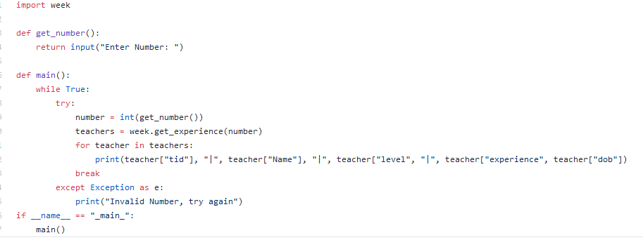

**Connection**

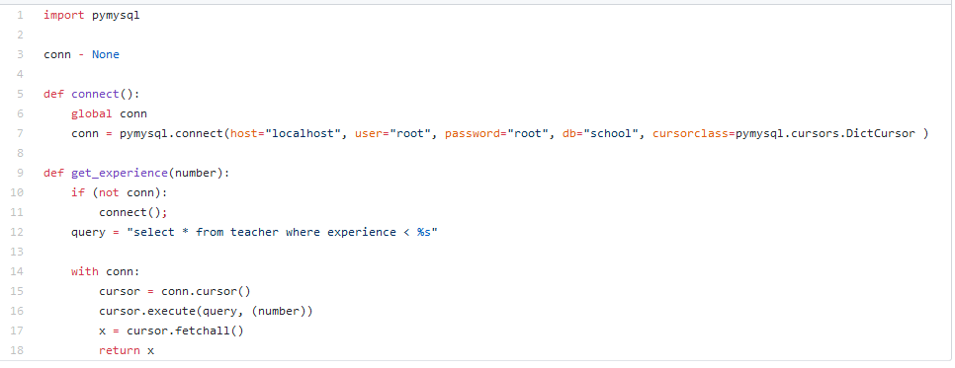

**Write a Python program that asks a user to enter details of a new subject and adds it to the database**